

Week-1 Report

Computer Vision-Super Image Resolution

| Roll No. | Name of the Student | Name of the Program |
| --- | --- | --- |
| AU1940109 | Jap Purohit | CV |
| AU1940034 | Varun Deliwala | CV |
| AU1940267 | Sahil Miskeen | CV |
| AU1940142 | Shail Patel | CV |

**Data Sets Used**

For this project we will be using popular image datasets. The datasets explored till now are CIFAR-10, CIFAR-100 and Imagenet. We are not able to load the Image Net dataset on to google colab due to its large size. The image net dataset is more visible than the cifar-100 and the cifar-10 dataset. The image net dataset has a dimension of 256*256. This resolution of images is much better than the 32*32 resolution on the CIFAR datasets.

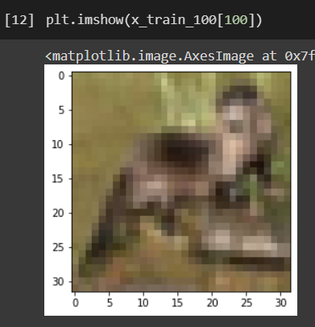

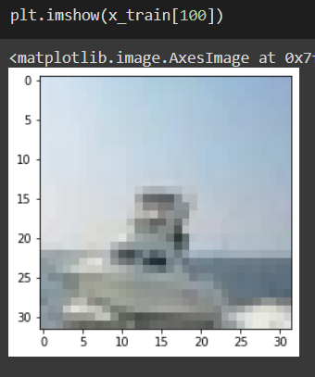

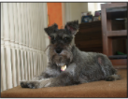

**Paper Reading**

For understanding the project in a better way we have started implementing a model based on the paper “1

Beyond a Gaussian Denoiser: Residual Learning of

Deep CNN for Image Denoising

Kai Zhang, Wangmeng Zuo, Yunjin Chen, Deyu Meng, and Lei Zhang”.

This paper talks about image to image mapping and would prove to be a foundation for our ultimate goal which is to super resolute an image. The paper talks about subtracting the noise from the image instead of directly giving the final image as the training parameter.

X = y - z

Here X represents the final output image, y represents the noisy image and z represents the noise in the image.

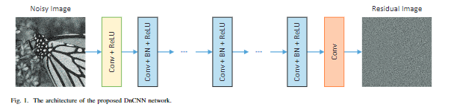

We have created a model for doing the same using keras library in python. The screenshot of which is pasted below.

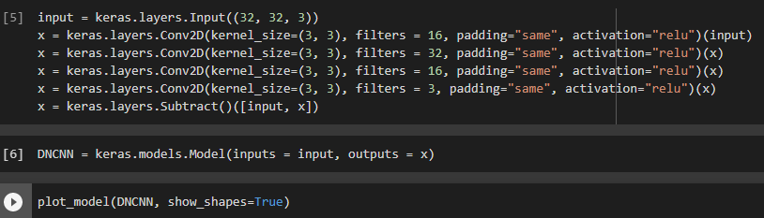

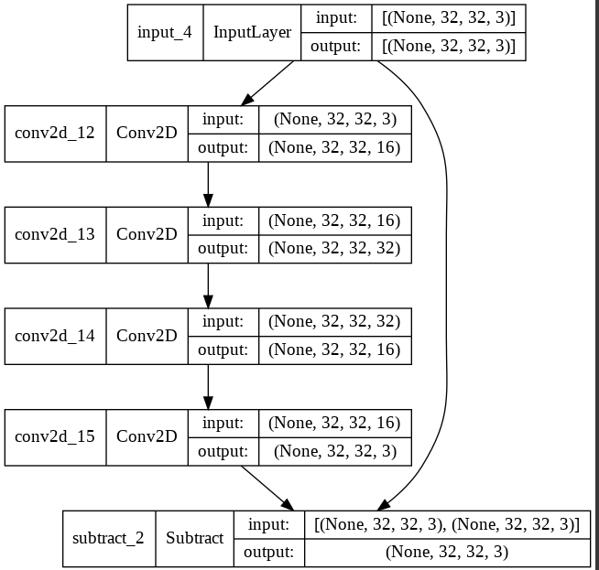

We started learning about GANS as well so we will try to replicate the GAN model in our next part of the project just to get a basic understanding of how they work in practice. Paper referred for the same is mentioned below.

Photo-Realistic Single Image Super-Resolution Using a Generative Adversarial Network

(Christian Ledig, Lucas Theis, Ferenc Husz´ar, Jose Caballero, Andrew Cunningham, Alejandro Acosta, Andrew Aitken, Alykhan Tejani, Johannes Totz, Zehan Wang, Wenzhe Shi Twitter)

The next step in our process will be to train this model on various datasets and increase the accuracy and complexity of the model by performing operations such as pooling, batch normalization and adding more layers as required.